File Attributes

1. Create a file abc.txt and change the ownership of this file to some other user on your machine,

and also change the group to family.

2. Create a file exercise.txt and make it executable.

3. Create a file test.txt on your desktop and identify its inode number, also create a softlink

for test.txt in your home.

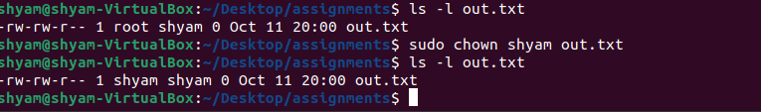

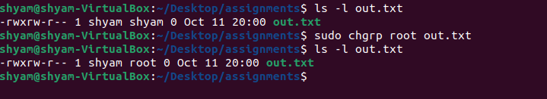

2. 

3.

